SCHOOL

Trial WACE Examination, 2010

Question/Answer Booklet

MATHEMATICS
SOLUTIONS

3A/3B(2)

Section Two:

Calculator-assumed

Student Number: In figures

In words

Your name

Time allowed for this section
Reading time before commencing work: 10 minutes
Working time for paper: 100 minutes

Material required/recommended for this section

To be provided by the supervisor
This Question/Answer booklet
Formula sheet (retained from Section One)

To be provided by the candidate
Standard items: pens, pencils, pencil sharpener, eraser, correction fluid, ruler, highlighters

Special items: drawing instruments, templates, notes on two unfolded sheets of A4 paper, and up to three calculators satisfying the conditions set by the Curriculum Council for this course.

Important note to candidates

No other items may be used in this section of the examination. It is your responsibility to ensure that you do not have any unauthorised notes or other items of a non-personal nature in the examination room. If you have any unauthorised material with you, hand it to the supervisor before reading any further.

Structure of this paper

Section | Number of questions available | Number of questions to be answered | Working time (minutes) | Marks available
Section One:  Calculator-free | 7 | 7 | 50 | 40
Section Two:  Calculator-assumed | 12 | 12 | 100 | 80
 |  |  |  | 120

Instructions to candidates

- The rules for the conduct of Western Australian external examinations are detailed in the Year 12 Information Handbook 2010. Sitting this examination implies that you agree to abide by these rules.

- Write your answers in the spaces provided in this Question/Answer Booklet. Spare pages are included at the end of this booklet. They can be used for planning your responses and/or as additional space if required to continue an answer.
- Planning: If you use the spare pages for planning, indicate this clearly at the top of the page.
- Continuing an answer: If you need to use the space to continue an answer, indicate in the original answer space where the answer is continued, i.e. give the page number. Fill in the number of the question(s) that you are continuing to answer at the top of the page.

- Show all your working clearly. Your working should be in sufficient detail to allow your answers to be checked readily and for marks to be awarded for reasoning. Incorrect answers given without supporting reasoning cannot be allocated any marks. For any question or part question worth more than two marks, valid working or justification is required to receive full marks. If you repeat an answer to any question, ensure that you cancel the answer you do not wish to have marked.

- It is recommended that you do not use pencil except in diagrams.

Section Two: Calculator-assumed (80 Marks)
This section has twelve (12) questions. Answer all questions. Write your answers in the space provided.

Working time for this section is 100 minutes.

Question 8 (5 marks)
A $5 note, a $10 note, another $10 note and a $20 note, all of the same size and shape, are placed into an opaque bag. A student puts their hand into the bag and randomly pulls out one of the notes and places it on a table. The student repeats this process, stopping when the value of the notes on the table has a total of at least $25.

(a) Draw a tree diagram to represent all the possible ways in which the notes can be drawn from the bag. (3 marks)
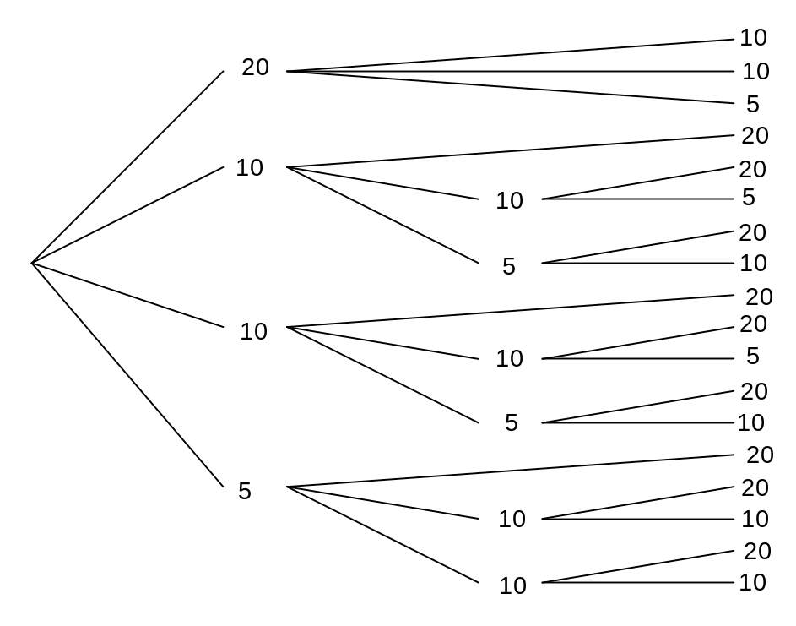

(b) If each way has an equal chance of happening, calculate

(i) the probability that the $5 note remains in the bag. (1 mark)

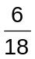

(ii) the probability that the total value of the notes is less than $35 given that the total is greater than $25. (1 mark)

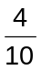

Question 9 (7 marks)
The heights of a group of children taking part in a survey are shown in the table below.
The 145 - 149 cm group had the second lowest frequency of all the groups.

Height (cm) | 145 - 149 | 150 - 154 | 155 - 159 | 160 - 164 | 165 - 169 | 170 - 174
Number of children |  | 35 | 54 | 48 | 29 | 18

(a) State the modal group for this data. (1 mark)
155 - 159 cm

(b) Calculate estimates for the mean and standard deviation of the heights of the children who were taller than 149.5 cm. (2 marks)
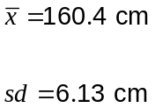

(c) Explain why your answers to part (a) are estimates. (1 mark)
The heights of individual students are unknown, so we have assumed that the mean height of the students in each group is equal to the midpoint of the group.

(d) The children in the 145 - 149 cm group are now included in calculations.

(i) Explain whether the standard deviation would be the same, smaller or greater than your answer in part (b). (1 mark)
SD will be greater, as the extra children are a long way from the mean and so increase the spread of the data.

(ii) Find , the number of children in this group, if the mean height is 158.8 cm when rounded to one decimal place. (2 marks)
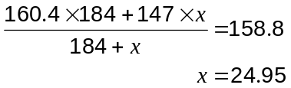

There were 25 children in this group.

Question 10 (7 marks)
A student won $2500 in a photographic competition and used it all to open a savings account. She then decided to add $130 every month to this account from her part-time job. She made the deposit on the first of each month and the savings bank paid interest on the last day of each month. The table below shows how her savings progressed each month.

Month  () | Starting Balance  (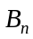) | Interest | Deposit | Next Balance  (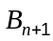)
0 | 2500.00 | 18.75 | 130.00 | 2648.75
1 | 2648.75 | 19.87 | 130.00 | 2798.62
2 | 2798.62 | 20.99 | 130.00 | 2949.61
3

(a) What was the annual percentage interest rate for the savings account? (1 mark)
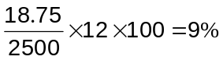

(b) State a recursive formula for, the amount in her account after her ^{th} deposit of $130.
(2 marks)
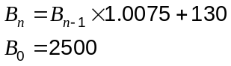

(c) Find 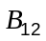, the amount in her account after her 12th deposit. (1 mark)
$4360.50

(d) How much interest had the student accumulated just after her 12th deposit? (2 marks)

(e) The student was planning to buy a car for $8000. How long before they would have saved this amount if the saving scheme continued? (1 mark)
After 33 months.

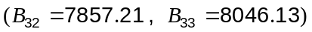
Question 11 (7 marks)
A project network for a task involving 13 separate jobs is shown below.

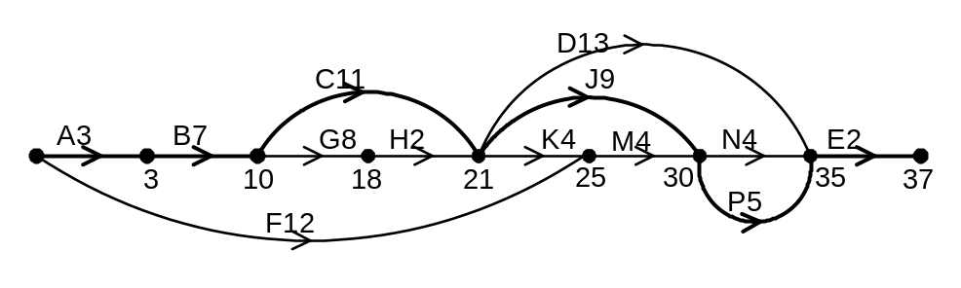

The length of time each job takes in weeks is given in the table below.

Job | A | B | C | D | E | F | G | H | J | K | M | N | P
Time | 3 | 7 | 11 | 13 | 2 | 12 | 8 | 2 | 9 | 4 | 4 | 4 | 5

(a) List all the tasks that must be completed before job K can commence. (1 mark)
A, B, C, G, H

(b) How many immediate predecessors does the final job have? (1 mark)
3 jobs

(c) What is the minimum number of weeks required to complete the task? You must show working either in the space below or on the diagram above to obtain full marks. (2 marks)
37 weeks

(d) List the jobs on the critical path in order of completion. (1 mark)
A, B, C, J, P, E

(e) If any one of the 13 jobs could be reduced in time by up to 4 weeks, which job should be chosen so that the minimum completion time is reduced by the maximum amount? Explain your answer and state the new minimum completion time. (2 marks)
Job B, with new MCT = 33 weeks.

Must be a job on the critical path to reduce MCT. None of the other 5 jobs lead to as large a reduction as B.

Question 12 (6 marks)
The graph of 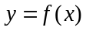 below has roots at (-1, 0), (2, 0) and (6, 0) and a -intercept at (0, -36).
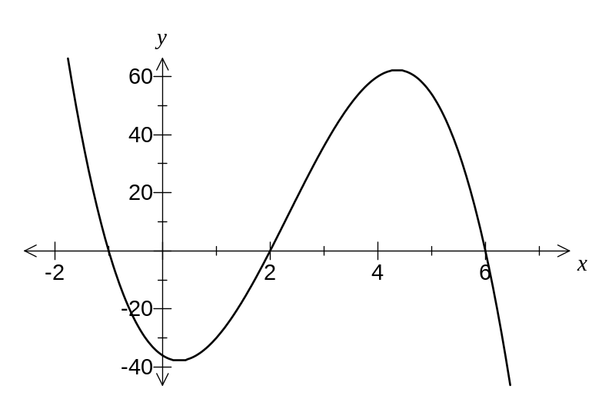

(a) Given 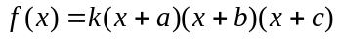, where , , and are constants, and 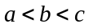, determine the values of , , and . (3 marks)
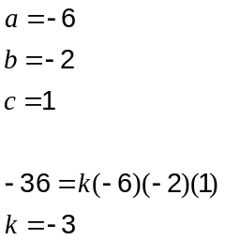

(b) State the following (no calculations required), rounding to one decimal place where required.

(i) The maximum value of  for 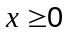. (1 mark)
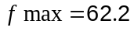

(ii) The coordinates of the point of inflection of . (1 mark)
(2.3, 12.2)

(iii) The values of for which of is concave upwards. (1 mark)
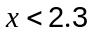
Question 13 (10 marks)
A company was concerned about the number of employees turning up late for work and implemented some changes to improve punctuality. Data was then collected on the numbers of employees arriving late for work over a period of 17 consecutive work days (Monday to Friday).

This data is shown in the table below, together with some calculated values based on this data.

() | Week | Day of Week | Number Late | 5-Day Moving Average () | Residual
1 | 1 | Friday | 21 | - | -
2 | 2 | Monday | 25 | - | -
3 | 2 | Tuesday | 25 | 22.6 | 2.4
4 | 2 | Wednesday | 21 | 22.2 | -1.2
5 | 2 | Thursday | 21 | 21.8 | -0.8
6 | 2 | Friday | 19 | 21.6 | -2.6
7 | 3 | Monday | A | 21.2 | 1.8
8 | 3 | Tuesday | 24 | 21.0 | 3.0
9 | 3 | Wednesday | 19 | 20.4 | -1.4
10 | 3 | Thursday | 20 | 20.0 | 0.0
11 | 3 | Friday | 16 | B
12 | 4 | Monday | 21 | 18.8 | 2.2
13 | 4 | Tuesday | 20 | 18.2 | 1.8
14 | 4 | Wednesday | 17 | 17.6 | -0.6
15 | 4 | Thursday | 17 | 17.2 | -0.2
16 | 4 | Friday | C | - | -
17 | 5 | Monday | 19 | - | -

The equation of the trend line fitted to the 5-day moving average is 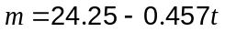 where is the time period in days, shown in the first column of the table. 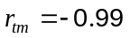.

(a) Explain why calculating a 5-day moving average is an appropriate way to smooth this data. (1 mark)
There is an obvious 5 day cycle of data based on the 5 working days of the week.

(b) Determine the values of A, B and C in the table above. (3 marks)
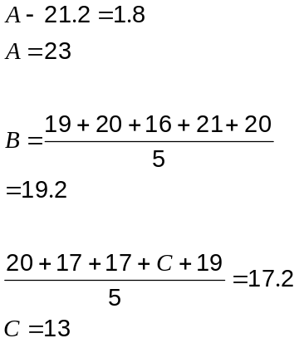

(c) What is the average change in the number of employees arriving late in a five-day cycle?
(1 mark)
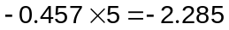

Decrease of 2.285 per week

(d) Calculate the seasonal component for Thursday and explain what its value means in the context of this question. (2 marks)
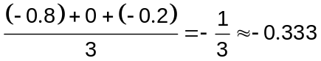

On Thursdays, the number of late employees is slightly (-0.333) below average.

(e) Predict the number of employees who will arrive late on the Thursday of Week 5.
(3 marks)
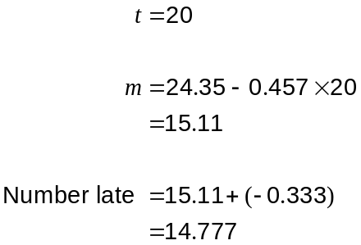

Hence expect 15 employees to be late.

Question 14 (9 marks)
The graph below shows the feasible region of a linear programming problem.
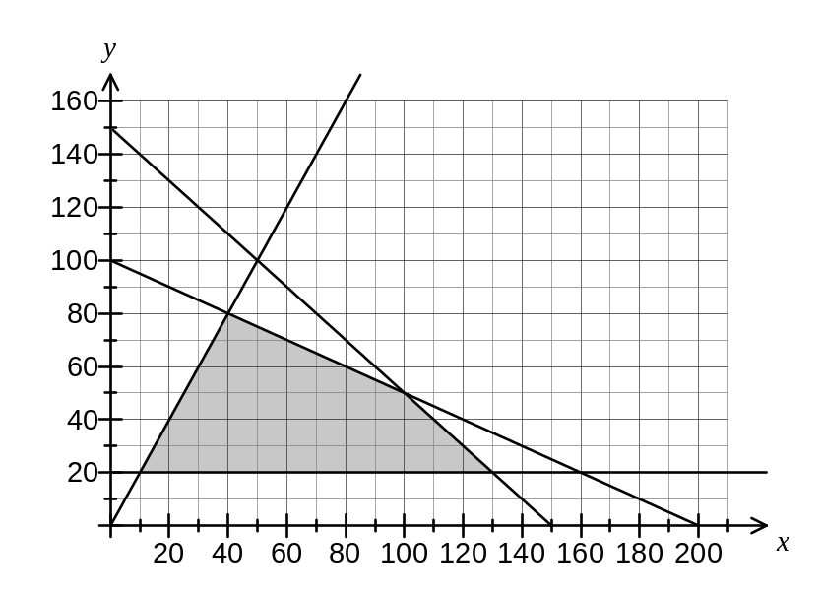
(a) State the three inequalities which define the feasible region shaded on the graph above other than . (3 marks)
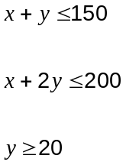

(b) Add the inequality 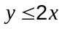 to the graph and clearly shade the new feasible region.
(2 marks)

(c) List the coordinates of the vertices of the feasible region found in part (b). (2 marks)
(10, 20)

(40, 80)

(100, 50)

(130, 20)

(d) State the coordinates of the point which maximises the objective function 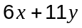.
(2 marks)
(10, 20) gives 280
(40, 80) gives 1120
(100, 50) gives 1150
(130, 20) gives 1000

Required point is (100, 50)

Question 15 (4 marks)
The graph shows the function 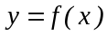.
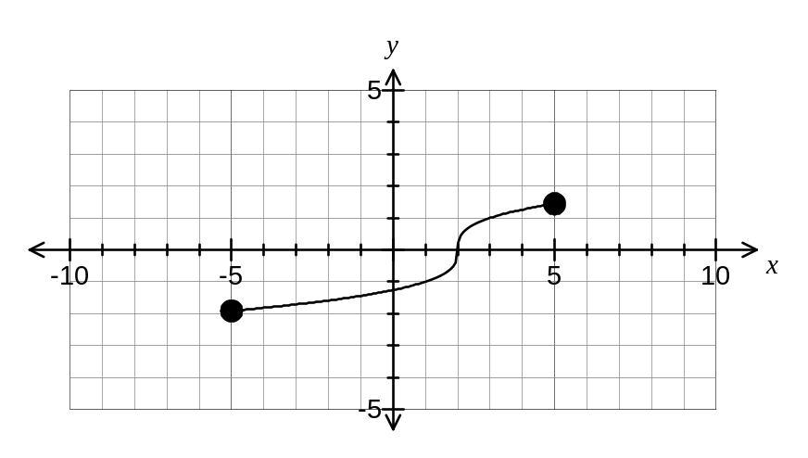

(a) Sketch the graph of 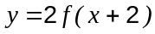. (2 marks)
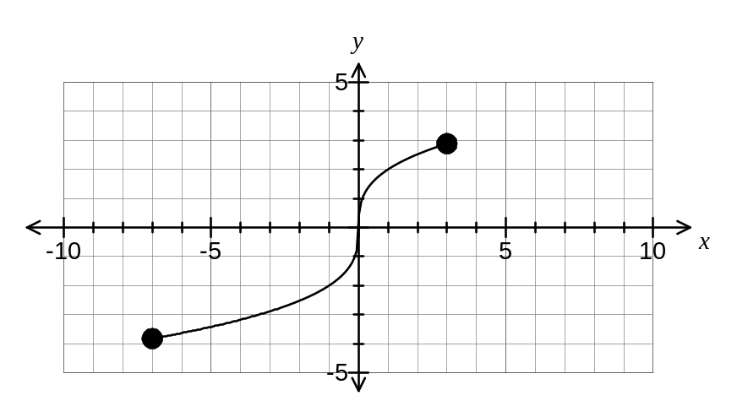

(b) Sketch the graph of 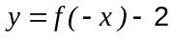. (2 marks)
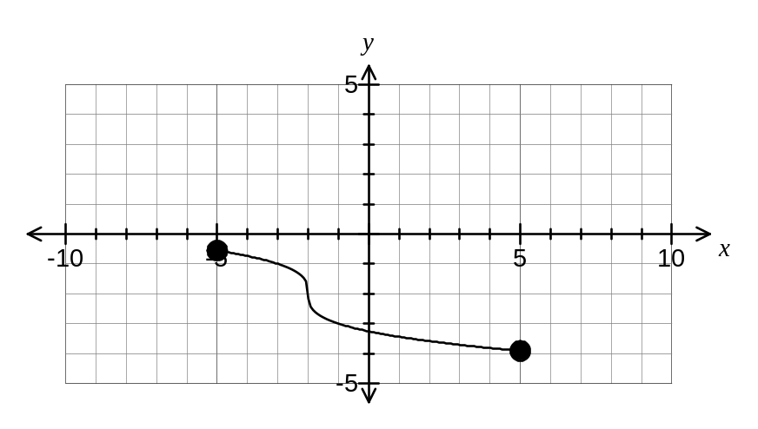
Question 16 (8 marks)
The following data was collected by a student interested in buying a second-hand sailing boat. It shows the age in years and the sale price, in hundreds of dollars, for 10 boats of the same type.

Age () | 3 | 13 | 5 | 14 | 5 | 10 | 6 | 12 | 4 | 9
Price () | 41 | 24 | 34 | 18 | 29 | 31 | 32 | 23 | 35 | 28

(a) Use your calculator to graph this data and by referring to features of your graph and a suitable statistic, explain why it is appropriate to fit a linear relationship to model the price of these boats against time. (2 marks)
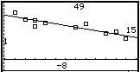

Points lie close to a straight line with no outliers.

The correlation coefficient of -0.905 is strong.

(b) Calculate the least-squares linear regression line of on . (1 mark)
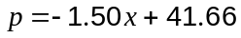

(c) The student saw another boat aged 15 years old advertised in the local paper. Use your line from part (b) to predict its sale price and comment on the reliability of your prediction.
(3 marks)
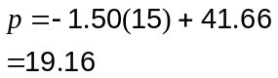

Sale price will be about $1900.

This prediction is reliable due to strong correlation between the variables and only a small amount of extrapolation beyond the supplied data.

(d) Calculate the price residual for the 10-year old boat and use your value to argue whether or not this boat is likely to be in better or worse condition compared to boats of a similar age. (2 marks)
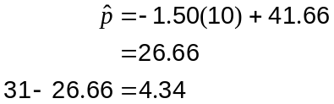

As the residual is positive, this indicates it is more expensive than similar boats, and so is likely to be in better condition.

Question 17 (6 marks)
The perimeter of the figure shown below is 192cm.

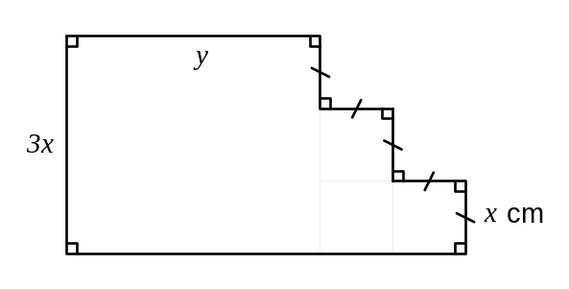

(a) Show that the area of the figure is given by 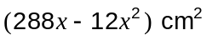. (3 marks)
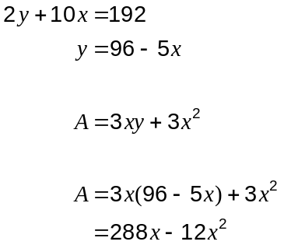

(b) Use differentiation to find the maximum area of the figure. (3 marks)
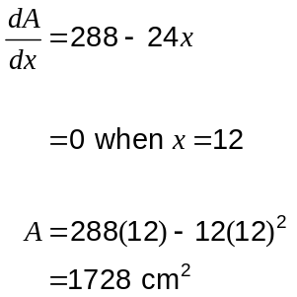

Question 18 (7 marks)
In the triangle below 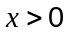,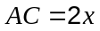,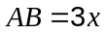, 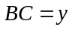 and 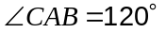.
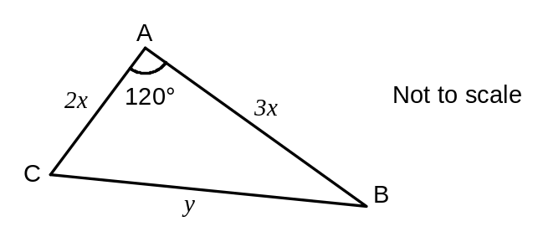

(a) Show that 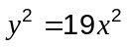. (2 marks)
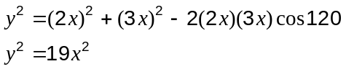

(b) Find the size of 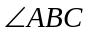. (3 marks)
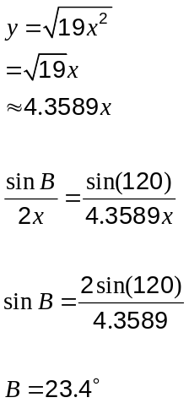

(c) If 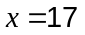cm, find the area of the triangle. (2 marks)
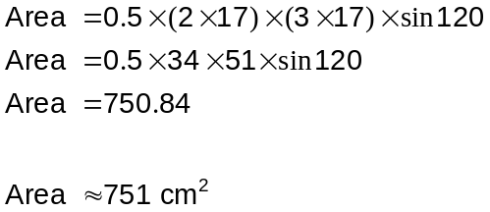

Question 19 (4 marks)
(a) Write down the equation of the tangent to 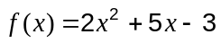 at the point where cuts the -axis. (1 mark)
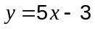

(b) Find an expression for the equation of the tangent to 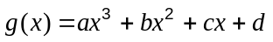 at the point where 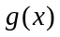 cuts the -axis in terms of , , and . (2 mark)
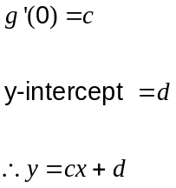

(c) Write down the equation of the tangent to 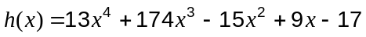 at the point where 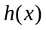 cuts the -axis. (1 mark)
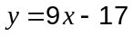

Additional working space

Question number(s):

